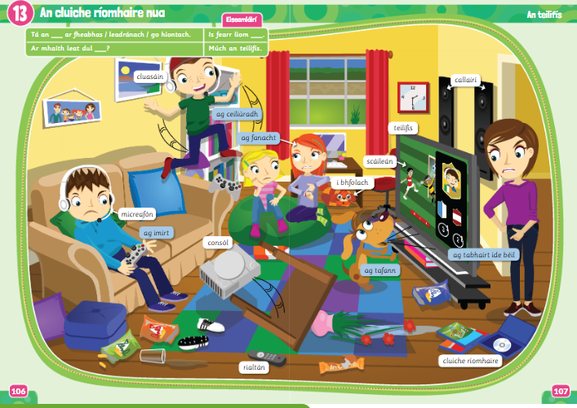
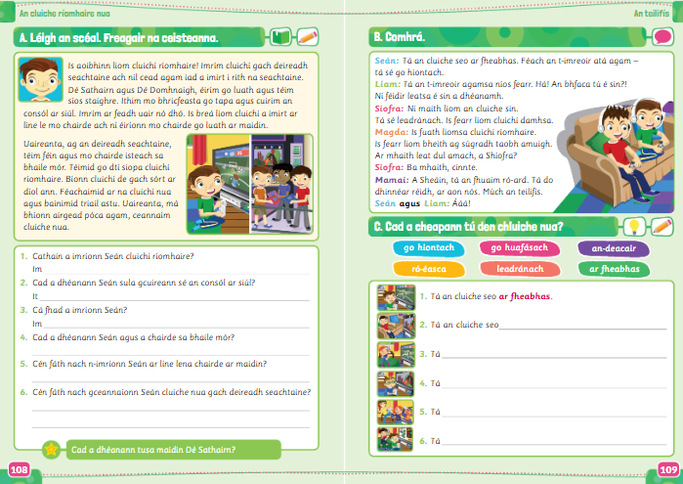
Vocabulary
Is aoibhinn liom – I love
Imrím – I play
Deireadh seachtaine – weekend
Níl cead agam – I’m not allowed
i rith na seachtaine – during the week
éirím – I get up
téim – I go / téimid – we go
Ithim – I eat
Go tapa – quickly
Cuirim an consól ar siúl – I put the console on
Ar feadh uair nó dhó – for an hour or two
ar líne – online
ní éiríonn mo chaired – my friends don’t get up
uaireanta – sometimes
bhaile mór – the big town
ar díol – for sale
bainimid triail astu – we try them
má – if
ceannaím – I buy
Q1. Cathain a imríonn Seán? –When does Sean play?
Q2. Cad a dhéanann Seán sula gcuireann sé an concól ar siúl? – What does Sean do before he puts on the console?
Q3. Cá fhad…? – How long does he play for
Q4. Cad a dhéanann Seán agus a chairde sa bhaile mór? – What does Sean and his friends do in the town? (Start with Téann Seán agus a chairde….. – Seán and his friends go….)
Q5. Cén fath nach n-imríonn Seán…..? – Why does Sean not play with his friends in the morning?
Q6. Cén fáth nach gceannaíonn…..? – Why does Sean not buy a new game every weekend? (Start with: Ní cheannaíonn Seán……mar (because) ní bhíonn airgead……)

Comhrá
Imreoir – player (like a character/game player) Níos fear – better
An bhfaca tú? – did you see?
Ní féidir leatsa – you can’t
Leadránach – boring
Is fearr liom – I prefer
Taobh amuigh – outside
Tá an fhuaim ró-ard – the sound is too high
Múch an teilifís – turn off the television
